Tabs Component

Items Tab

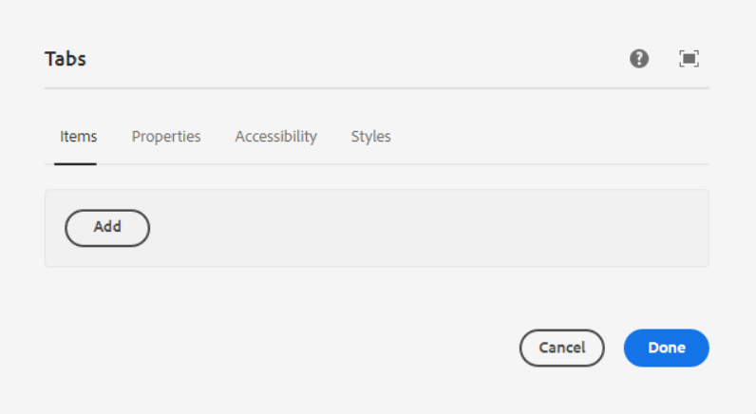

Inside Items Tab, we can add container component.

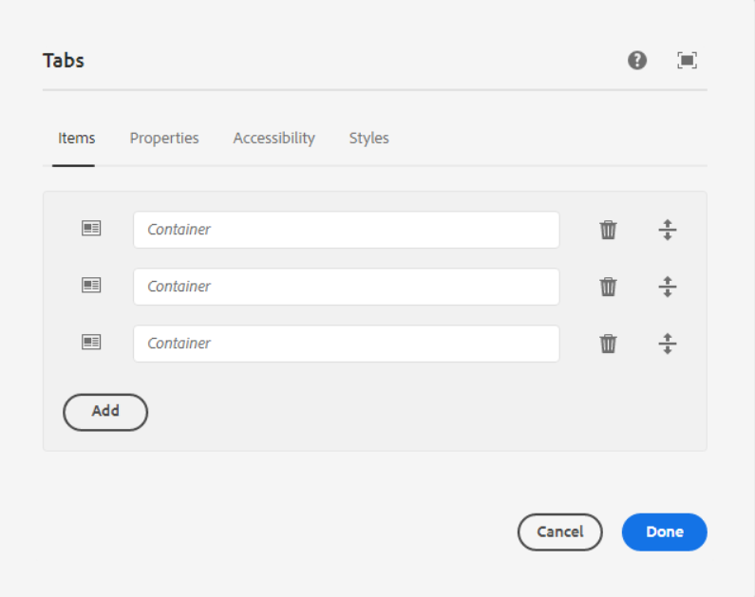

We can add or delete items as pe the requirement.

Properties Tab

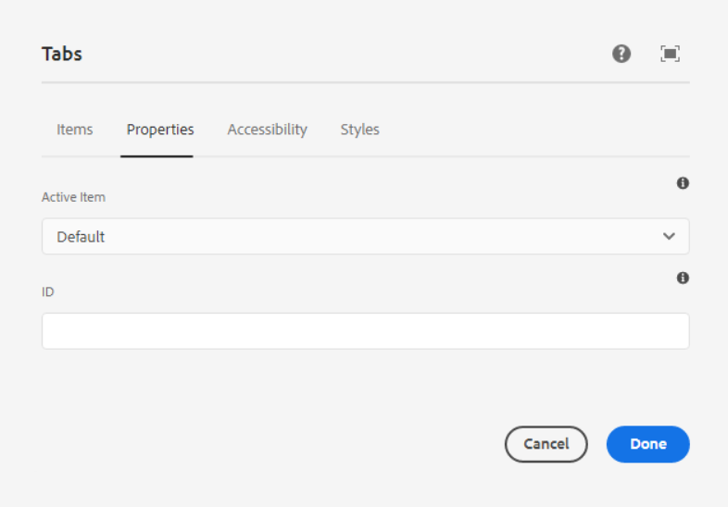

**Active Item** - The item that is active by default.

**ID** - HTML ID attribute to apply to the component.

Accessibility Tab

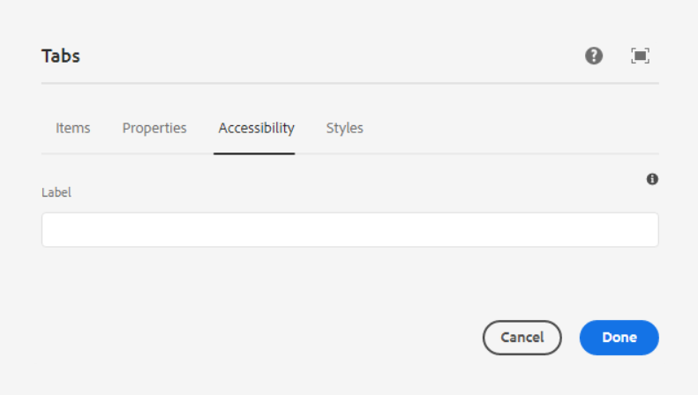

**Label** - Value of an aria-label attribute, which describes the purpose of the set of tabs.

Styles Tab

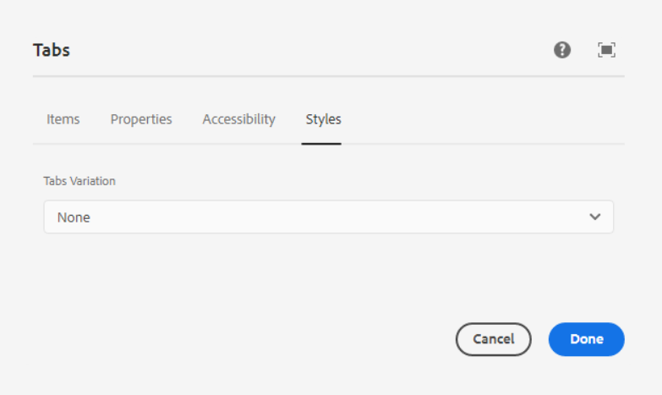

**Tabs Variation** – In this dropdown, we have 2 below options, we can select any one as per our requirement.

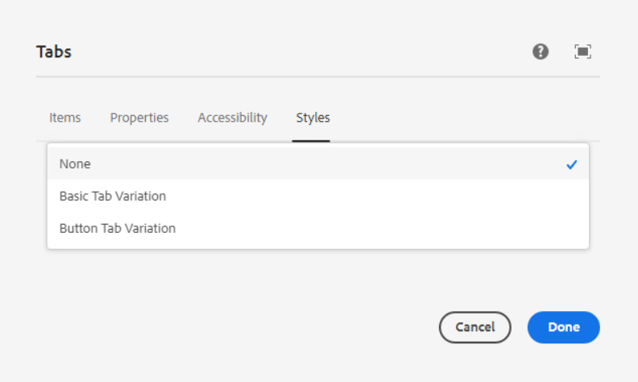

1. **Basic Tab Variation**

**Page Reference -** [**https://www.ancestry.com/corporate/about-ancestry/our-team**](https://www.ancestry.com/corporate/about-ancestry/our-team)

**AEM URL -** [**https://author-ancestry-dev2.adobecqms.net/content/ancestry-corp/us/en/about-ancestry/our-team.html?wcmmode=disabled**](https://author-ancestry-dev2.adobecqms.net/content/ancestry-corp/us/en/about-ancestry/our-team.html?wcmmode=disabled)



1. **Button Tab Variation**

**Page Reference -** [**https://www.ancestry.com/corporate/community-impact**](https://www.ancestry.com/corporate/community-impact)

**AEM URL** - [**https://author-ancestry-dev2.adobecqms.net/content/ancestry-corp/us/en/community-impact.html?wcmmode=disabled**](https://author-ancestry-dev2.adobecqms.net/content/ancestry-corp/us/en/community-impact.html?wcmmode=disabled)

